OpenClaw Deployment Guide
A Beginner-Friendly Step-by-Step Tutorial
Author: William Fan

Table of Contents
1. Introduction
2. Prerequisites
3. Creating the Lightsail Instance
4. Installing OpenClaw
5. Setting Up the API Key
6. Setting Up the SSH Tunnel
7. Accessing the OpenClaw Dashboard
8. Security Hardening
9. Connecting Telegram
10. Troubleshooting

1. Introduction
OpenClaw is an AI agent framework that lets you run your own personal AI assistant in the cloud. Think of it as setting up your own "brain" that can talk to you through a web dashboard or messaging apps like Telegram, process information using AI models like Claude, and perform automated tasks on your behalf.
This guide walks you through every step of deploying OpenClaw on an Amazon Web Services (AWS) Lightsail server. By the end, you will have:
- A cloud server running your personal OpenClaw agent
- Secure access to the OpenClaw dashboard from your computer
- AI capabilities powered by Anthropic Claude
- A Telegram bot connected to your agent for mobile access
No prior coding or server experience is required. Each step includes the exact commands to type and screenshots showing what you should see.

What is the Architecture?
The diagram below shows how all the pieces fit together: your computer connects through a secure SSH tunnel to the cloud server, which runs the OpenClaw gateway. The gateway communicates with AI models and messaging platforms on your behalf.
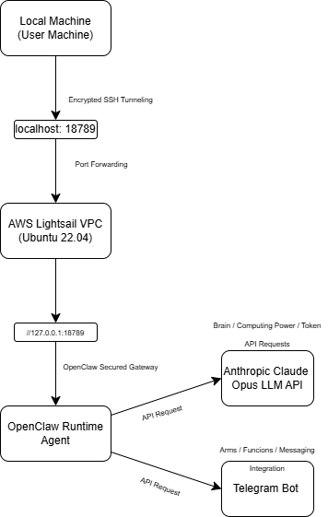
Figure 1. Network topology showing how your computer, the cloud server, AI models, and Telegram connect together.

How Communication Works
Step 1: You open your browser — Navigate to http://localhost:18789 — this connects to OpenClaw through a secure tunnel.
Step 2: The SSH tunnel encrypts traffic — Your browser talks to the cloud server through an encrypted connection, so nobody can eavesdrop.
Step 3: The OpenClaw Gateway processes requests — The gateway runs on the cloud server and manages everything — your conversations, tools, and integrations.
Step 4: AI models generate responses — When you chat with OpenClaw, it sends your messages to Claude (or another AI model) and returns the response.
Step 5: Telegram provides mobile access — Once connected, you can also chat with your agent from your phone using Telegram.

2. Prerequisites
Before you begin, make sure you have the following:
An AWS account: Sign up at https://aws.amazon.com if you don't have one. Lightsail offers a 3-month free tier for new users.
A computer with internet access: Windows, macOS, or Linux — any will work.
A web browser: Chrome, Firefox, Edge, or Safari.
PowerShell or Terminal: Windows users will use PowerShell. macOS/Linux users will use Terminal.
A Telegram account (optional): Only needed if you want to chat with your agent from your phone.
An Anthropic account: Sign up at https://console.anthropic.com to get an API key for Claude.
💡 Budget tip: AWS Lightsail's free tier covers the first 3 months. The Anthropic API charges per usage — set a spending limit (covered in Step 5) to avoid surprises.

3. Creating the Lightsail Instance
An "instance" is just a virtual computer that runs in Amazon's cloud. We'll create one that runs Ubuntu Linux, which is the operating system OpenClaw needs.

Step 3.1 — Open AWS Lightsail
Log in to your AWS account and navigate to the Lightsail console. You can find it by searching for "Lightsail" in the AWS search bar, or go directly to:
https://lightsail.aws.amazon.com
Click "Create instance" to begin setting up your virtual server.
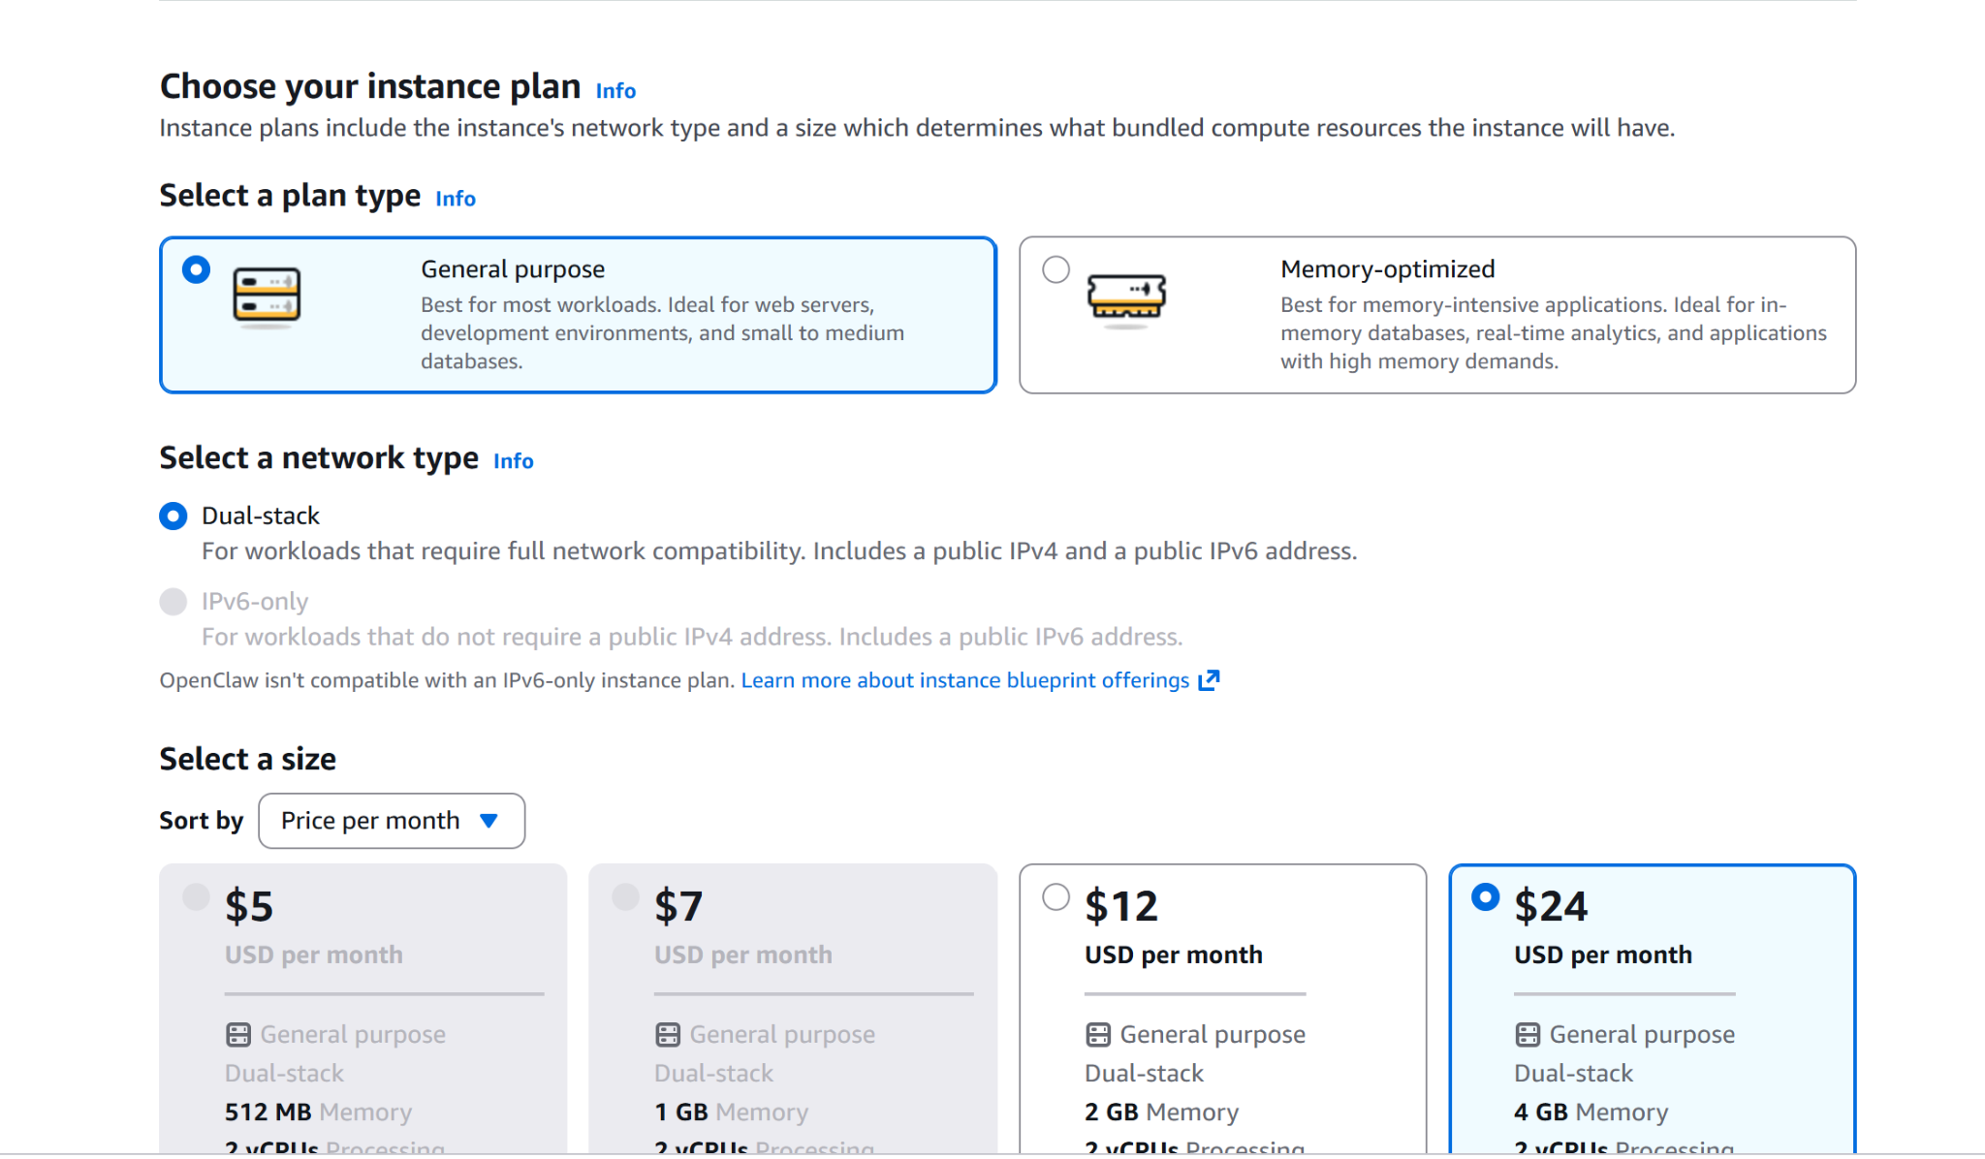
Figure 2. The AWS Lightsail instance creation page where you select your operating system and plan.

Step 3.2 — Choose Your Instance Settings
Configure the instance with the following settings:
Platform: Linux/Unix
Operating System: Ubuntu 22.04 LTS
Instance Plan: $20/month — 4 GB RAM, 2 vCPUs, 80 GB SSD
⚠️ Do not use the $12 plan or smaller. The author tested it and found it runs out of memory during OpenClaw installation. The $20 plan is the minimum that works reliably.
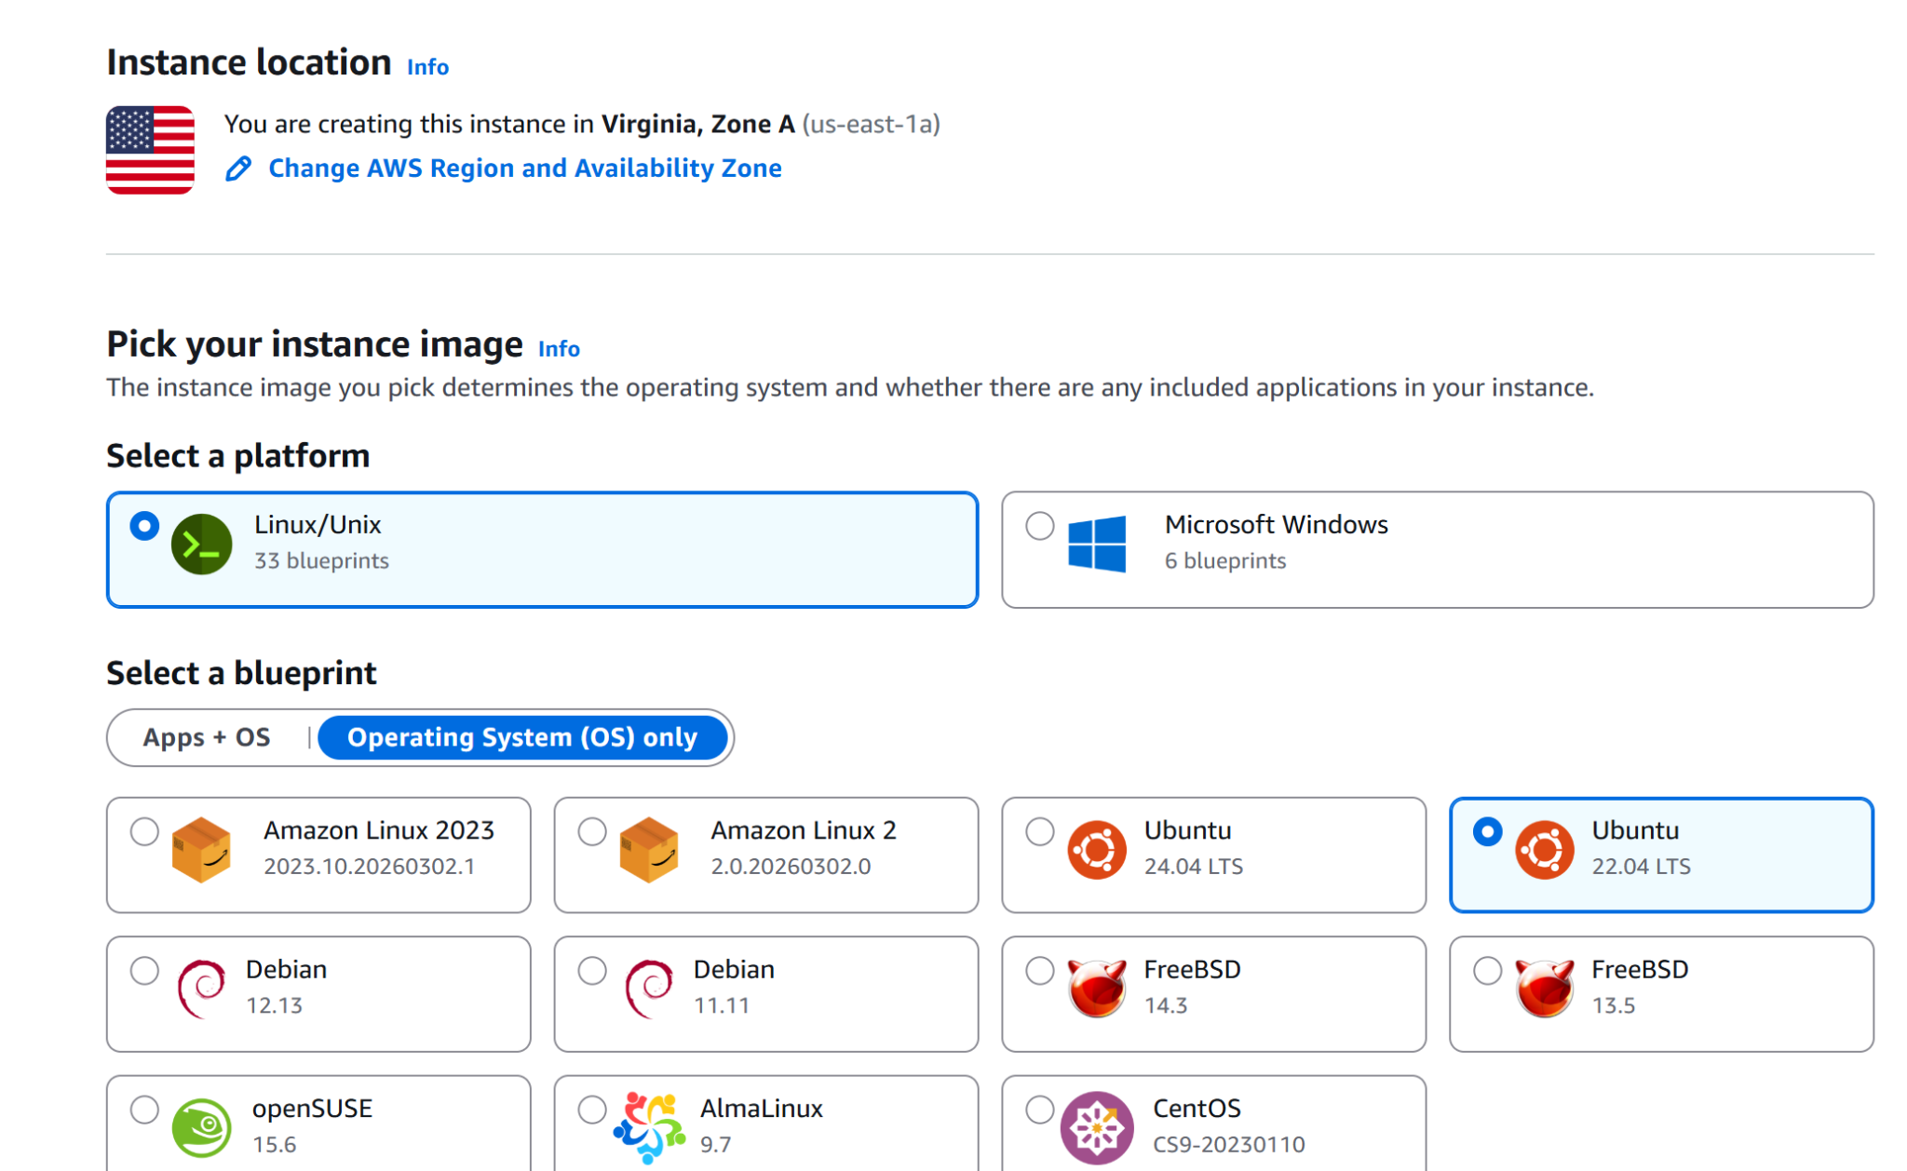
Figure 3. Selecting the instance size — choose the 4 GB RAM plan for reliable performance.

Step 3.3 — Launch and Access Your Instance
After creating the instance, you'll see it in your Lightsail dashboard. Wait a moment for it to finish starting up (the status will change to "Running").
From the dashboard, you can start, stop, reboot, and connect to your server using the built-in browser-based SSH terminal by clicking the terminal icon or "Connect using SSH."
💡 AWS Lightsail offers a 3-month free trial for new users, which is enough time to complete this project. When you're not using the instance, stop it to save resources.
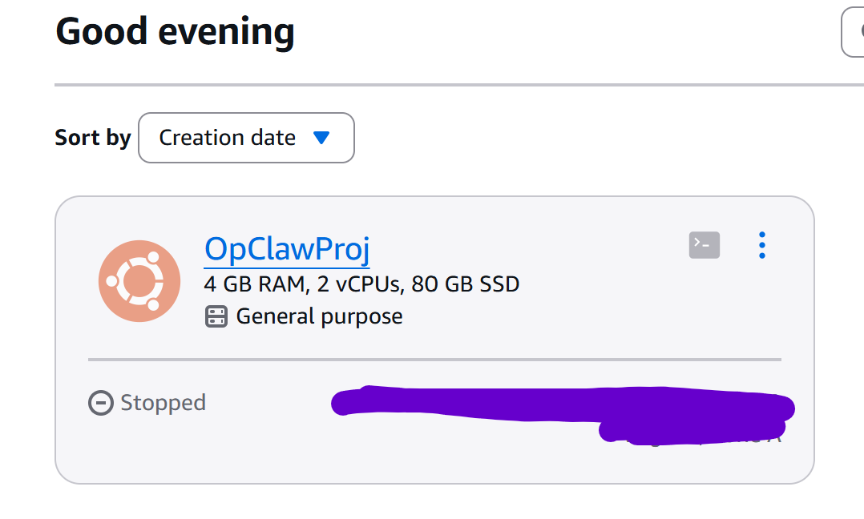
Figure 4. The Lightsail dashboard showing your running instance with management controls.

4. Installing OpenClaw
Now that your cloud server is running, it's time to install OpenClaw on it. This process downloads and sets up everything OpenClaw needs automatically.

Step 4.1 — Connect to Your Server
From your Lightsail dashboard, click "Connect using SSH" to open a terminal window in your browser. This gives you a command line on your cloud server.

Step 4.2 — Run the Installation Script
Visit the official OpenClaw website and find the Quick Start section. Copy the installation command and paste it into the SSH terminal. The command will look something like:
curl -fsSL https://get.openclaw.ai | bash
This downloads the OpenClaw installer and runs it automatically. The installation may take several minutes depending on your server's speed. You'll see progress messages as it installs Node.js and the OpenClaw CLI.
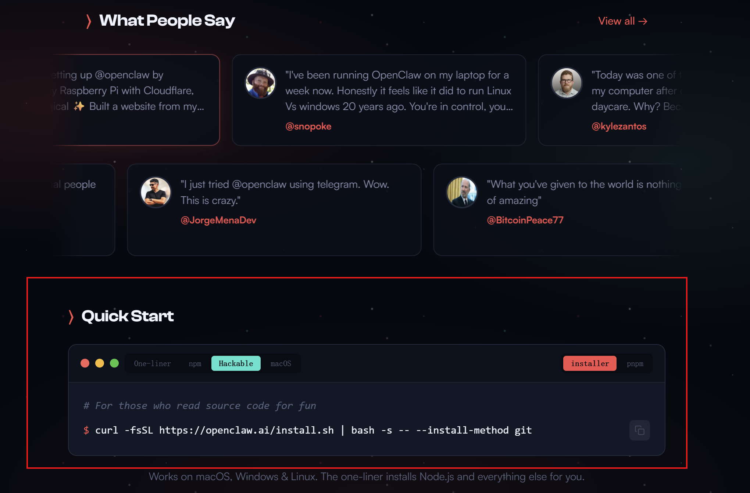
Figure 5. The OpenClaw installation script running in the Lightsail SSH terminal.

Step 4.3 — Verify the Installation
After installation completes, verify that OpenClaw is working by running:
openclaw
If the command is not found, use the full path instead:
/home/ubuntu/.local/bin/openclaw
You should see a list of available OpenClaw commands, confirming the installation was successful.
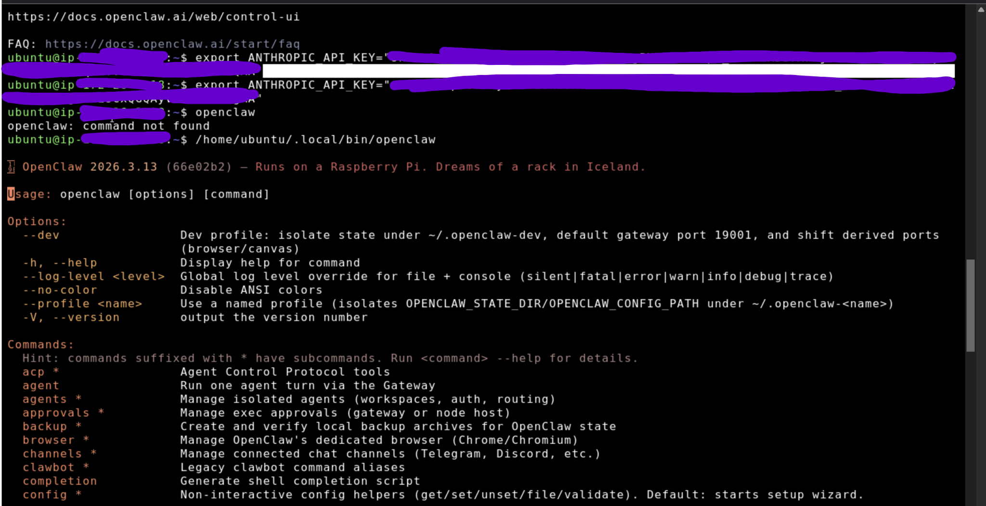
Figure 6. Successful OpenClaw installation showing available CLI commands.

5. Setting Up the API Key
OpenClaw needs access to an AI model to generate responses. In this guide, we use Anthropic's Claude. You'll create an API key (like a password for the AI service) and tell OpenClaw about it.

Step 5.1 — Create an Anthropic API Key
While OpenClaw installs (or after), open a new browser tab and go to:
https://platform.claude.com/settings/keys
Click "Create Key" and give it a descriptive name (for example, "OpClawProj_Key"). The platform will show you the key — this is the only time you'll see it.
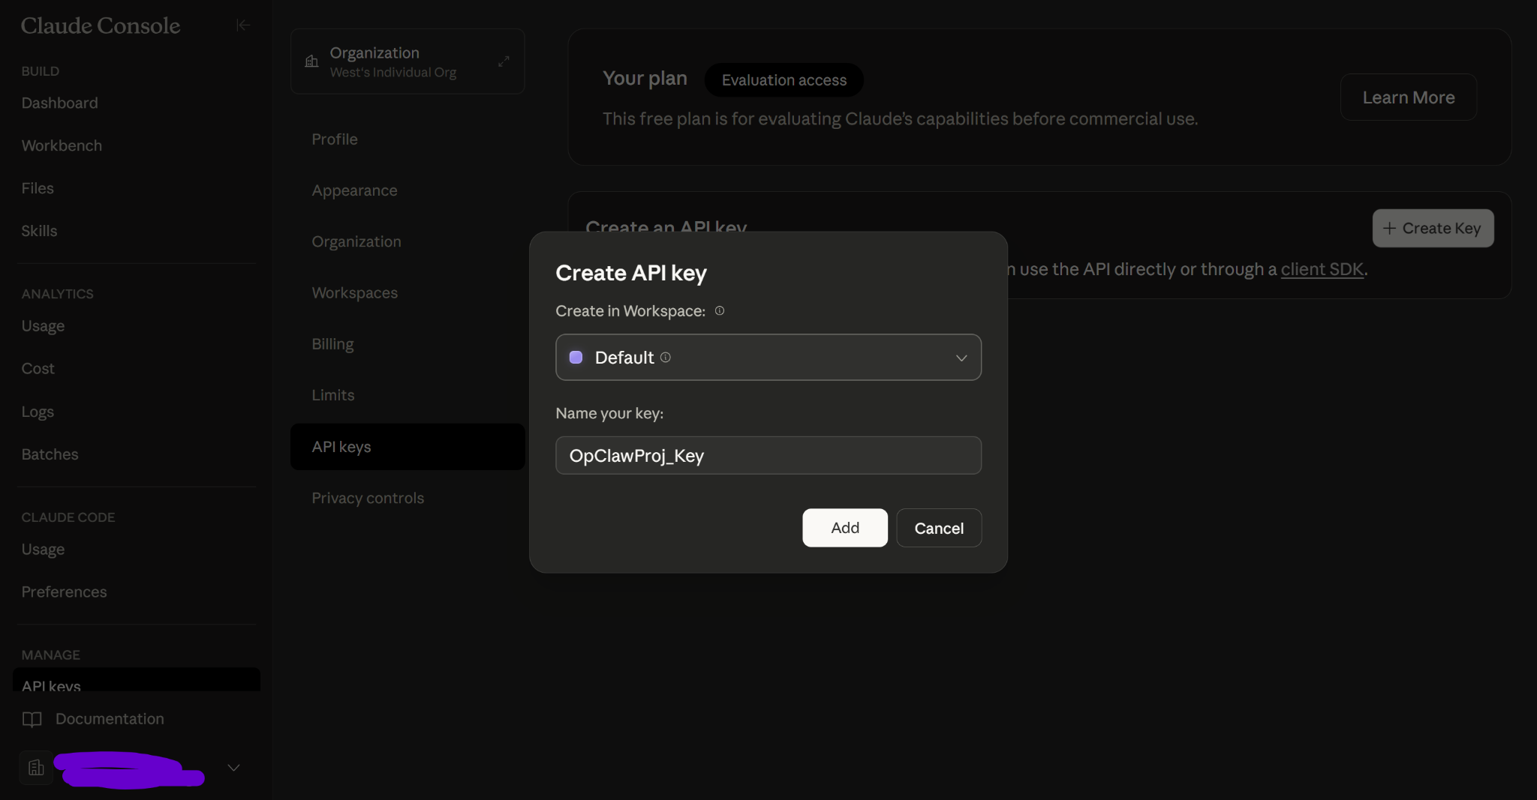
Figure 7. Creating a new API key in the Anthropic Claude platform.

Step 5.2 — Save the Key Securely
Immediately copy the API key and store it in a safe place like a password manager. This key allows access to AI computing resources, so treat it like a password — never share it publicly or commit it to code repositories.
⚠️ If someone gets your API key, they can use your account and you'll be billed for their usage. Keep it secret!
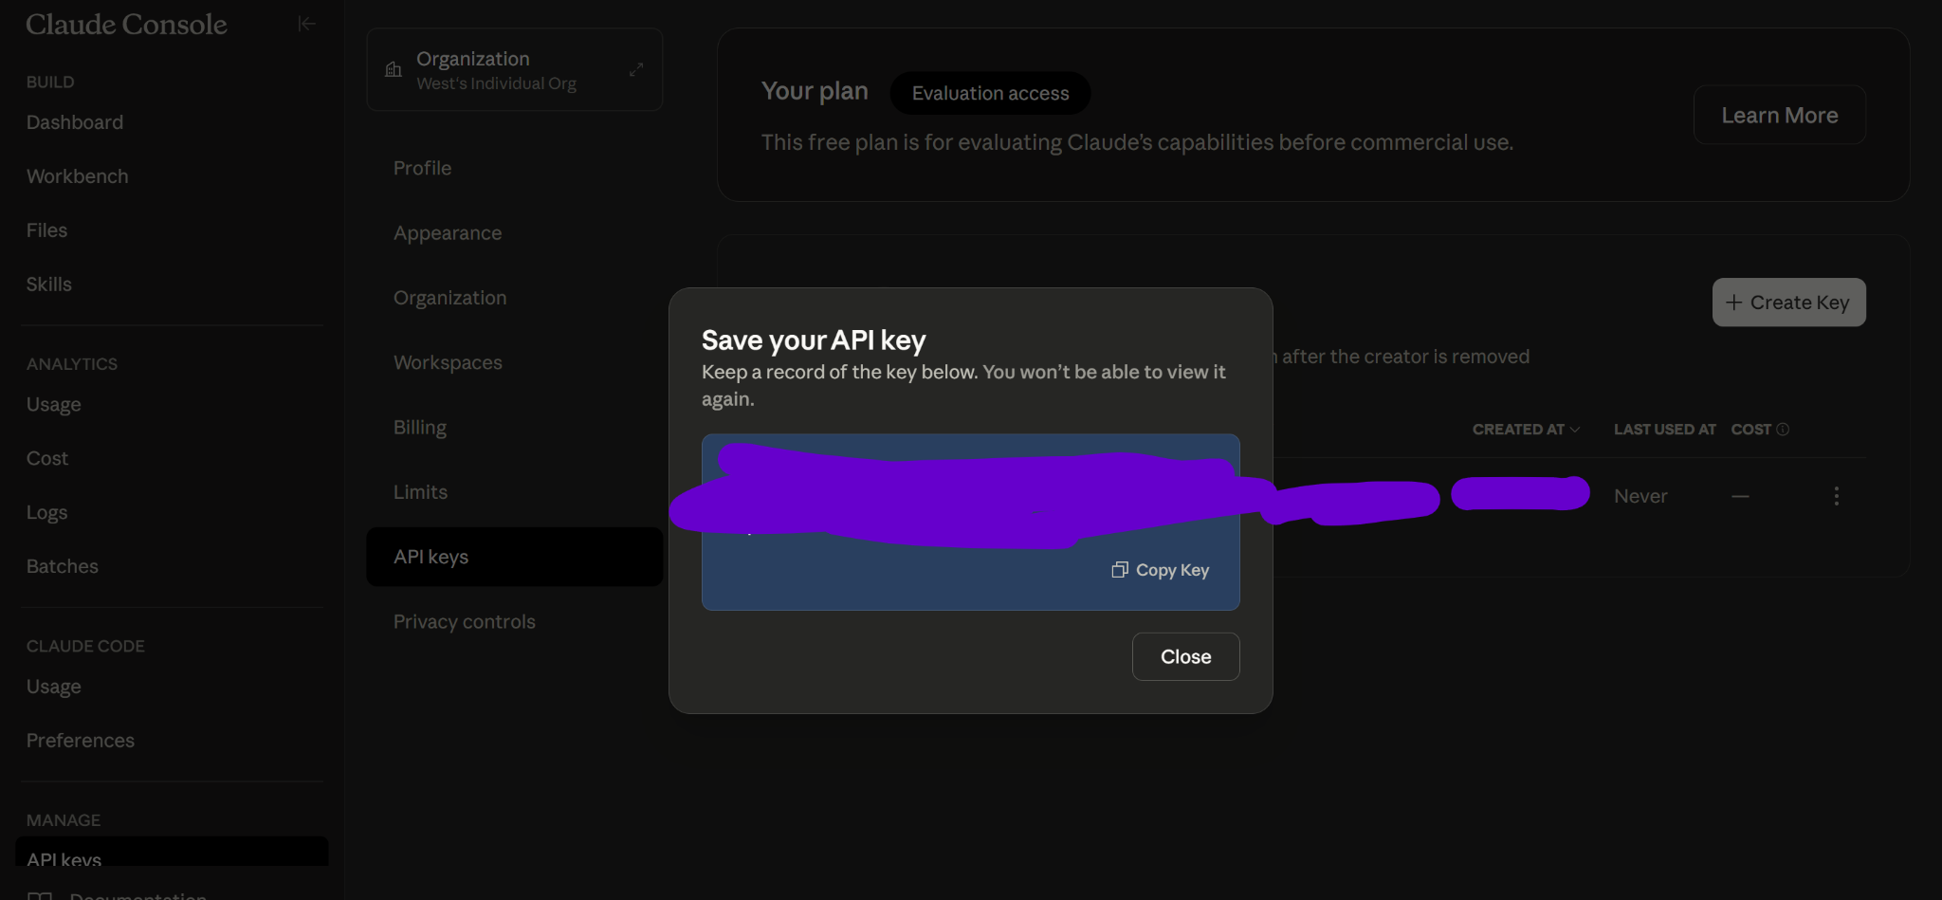
Figure 8. The API key is shown only once — copy and save it immediately.

Step 5.3 — Set a Spending Limit
AI API usage costs money based on how much you use it. To avoid surprise charges, set a monthly spending limit in the Claude dashboard under the "Limits" section. Start with a small amount (like $5–10) while you're learning.
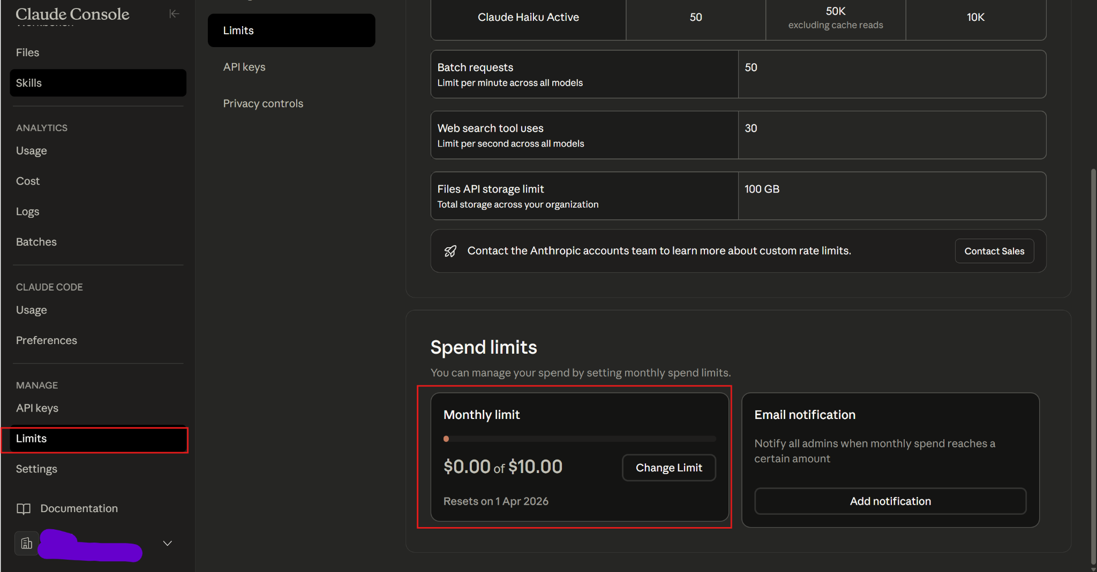
Figure 9. Setting a monthly spending limit in the Anthropic dashboard to control costs.

Step 5.4 — Import the Key to Your Server
Go back to your Lightsail SSH terminal and run the following command, replacing the placeholder with your actual API key:
export ANTHROPIC_API_KEY="your_api_key_here"
This tells the server where to find your AI credentials so OpenClaw can use Claude to generate responses.
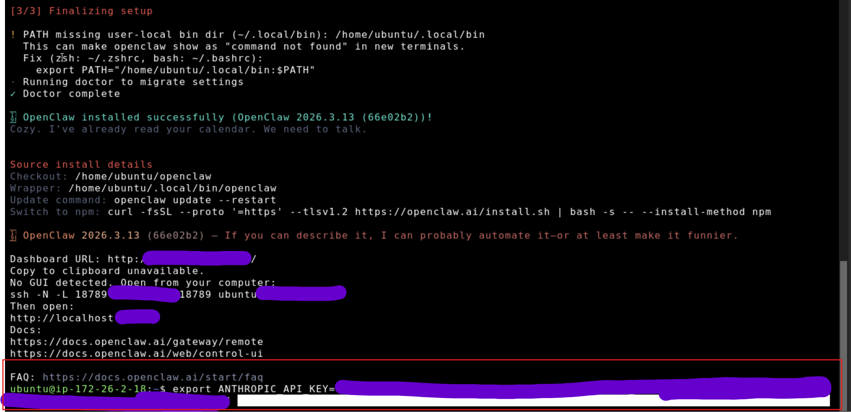
Figure 10. Exporting the API key as an environment variable on the Lightsail server.

6. Setting Up the SSH Tunnel
The OpenClaw dashboard runs on your cloud server but is not exposed to the internet (for security). To access it from your computer, you'll create an "SSH tunnel" — a secure, encrypted connection that lets your browser talk to the server as if it were running locally.

Step 6.1 — Get the Gateway Token
First, you need an authentication token for the dashboard. In the Lightsail SSH terminal, open a new terminal tab and run:
/home/ubuntu/.local/bin/openclaw dashboard --no-open
This generates a URL containing your gateway token. Copy and save this token — you'll need it to log in to the dashboard.
💡 Save the token in your password manager alongside your API key. You'll need it every time you access the dashboard.
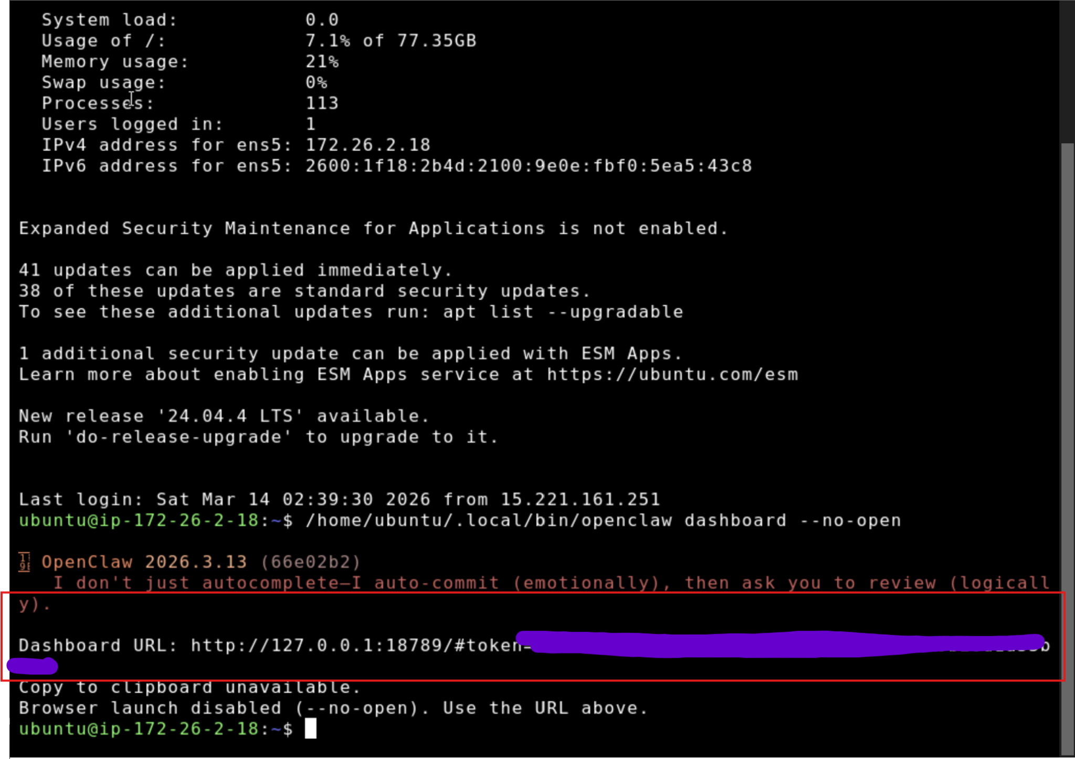
Figure 11. The gateway token URL generated by the OpenClaw CLI — copy and save this.

Step 6.2 — Create the SSH Tunnel (Option A: Password/Default Auth)
Open PowerShell (Windows) or Terminal (macOS/Linux) on your local computer — not the Lightsail browser terminal. Run this command, replacing <SERVER_IP> with your Lightsail instance's public IP address:
ssh -N -L 18789:127.0.0.1:18789 ubuntu@<SERVER_IP>
Here's what each part means:
ssh — The secure shell command that creates encrypted connections.
-N — Tells SSH not to run any commands — just keep the tunnel open.
-L 18789:127.0.0.1:18789 — Forwards your local port 18789 to the server's port 18789.
ubuntu@<SERVER_IP> — Connects as the "ubuntu" user to your server's IP address.
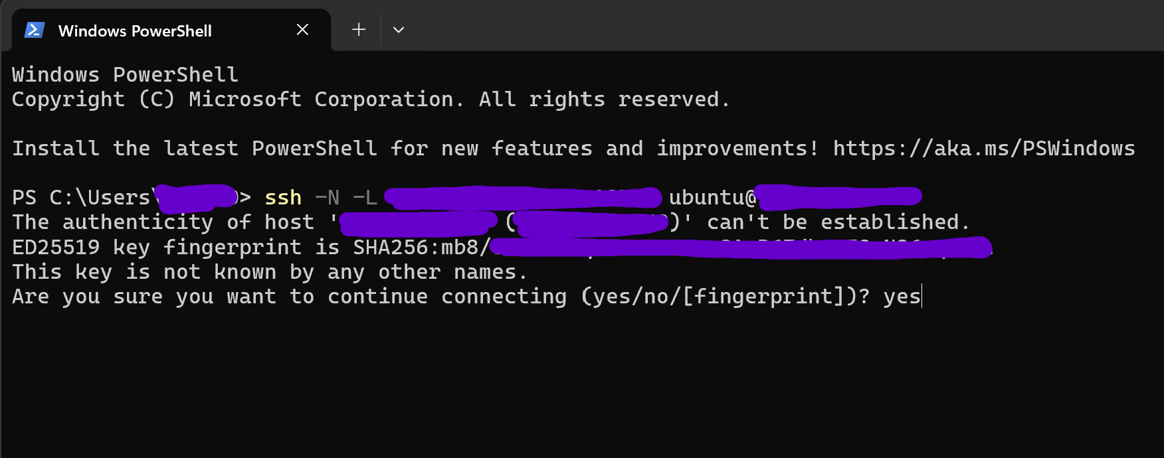
Figure 12. Running the SSH tunnel command in PowerShell — the terminal stays open while the tunnel is active.

Step 6.3 — Create the SSH Tunnel (Option B: Using a .pem Key)
If Option A doesn't work, you may need to download the SSH key from Lightsail. Go to your instance's "Connect" tab in the Lightsail dashboard and download the default SSH key (.pem file).
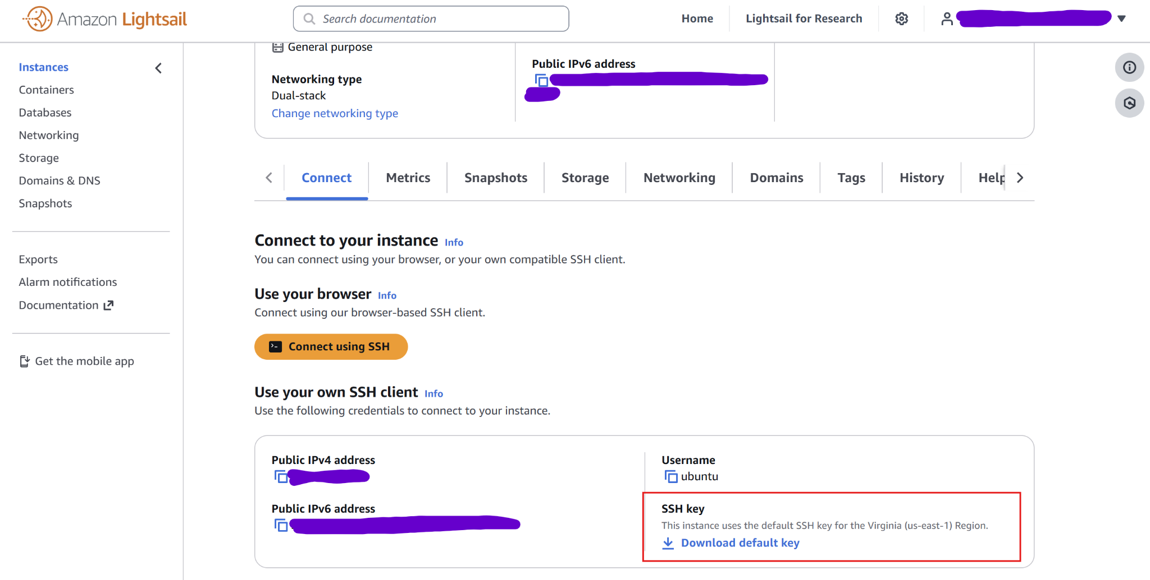
Figure 13. Downloading the SSH private key from the Lightsail instance Connect tab.
Then run this command instead, replacing the placeholders:
ssh -i LightsailDefaultKey.pem -N -L 18789:127.0.0.1:18789 ubuntu@<SERVER_IP>
The extra part:
-i LightsailDefaultKey.pem — Points to the private key file you downloaded. Make sure the path is correct.
⚠️ If you get a "permissions too open" error on the key file, run: chmod 400 LightsailDefaultKey.pem
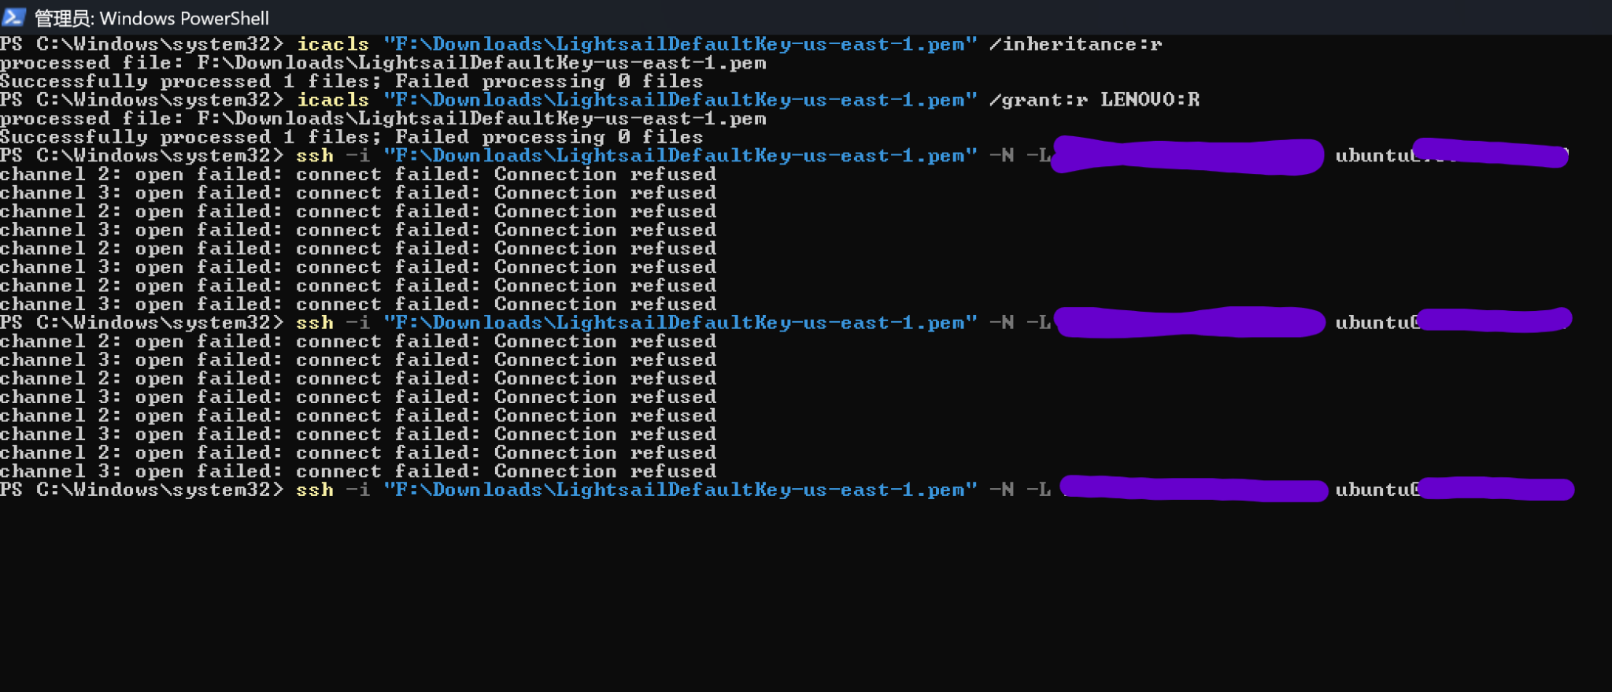
Figure 14. SSH tunnel using the .pem key file — the terminal stays open with no output, which means it's working.

7. Accessing the OpenClaw Dashboard
With the SSH tunnel running, you can now access the OpenClaw dashboard from your browser as if it were running on your own computer.

Step 7.1 — Open the Dashboard
While your SSH tunnel is running (the PowerShell/Terminal window stays open), open your web browser and go to:
http://localhost:18789
Even though OpenClaw is running on a server thousands of miles away, the SSH tunnel makes it appear as if it's on your local machine. You should see the OpenClaw Gateway login screen.
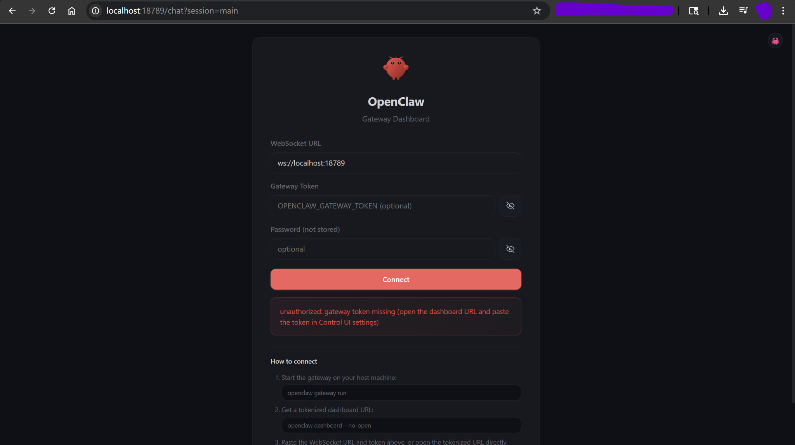
Figure 15. The OpenClaw Gateway dashboard login screen loaded through the SSH tunnel.

Step 7.2 — Enter the Gateway Token
Paste the gateway token you saved earlier (from Step 6.1) into the "Gateway Token" field and click "Connect."
If everything is set up correctly, you'll be taken to the OpenClaw chat interface — your personal AI agent is now live!
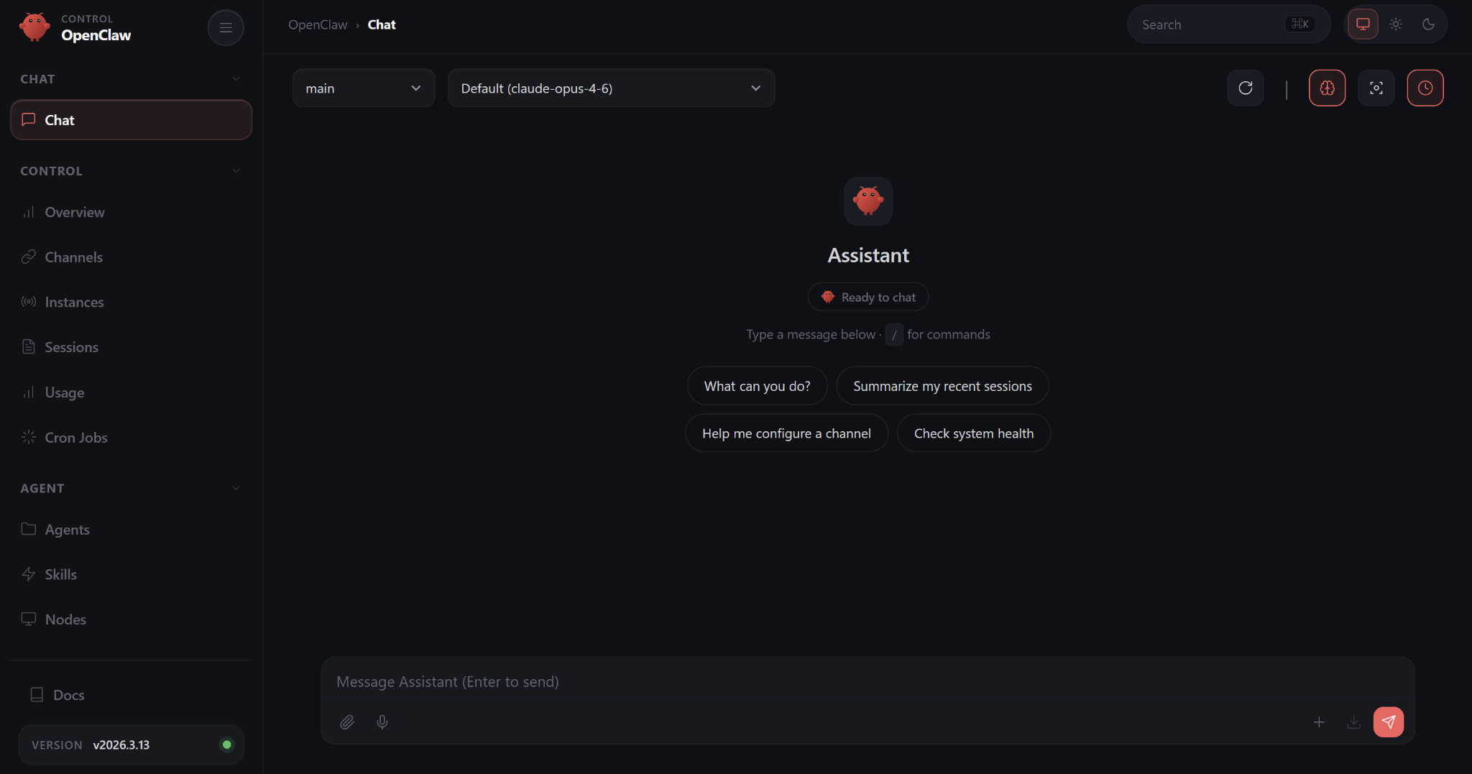
Figure 16. Successfully connected to the OpenClaw agent — the chat interface is ready to use.

8. Security Hardening
Now that OpenClaw is running, it's important to set up security rules. Since the agent can perform actions on your behalf, you want to make sure it asks for permission before doing anything sensitive.

Step 8.1 — Run a Security Audit
The OpenClaw agent can check its own security configuration. The official security guidelines are available at:
https://docs.openclaw.ai/gateway/security
You can ask the agent to run a security audit by typing a request in the chat interface. The agent will check file permissions, directory access levels, and gateway configuration.
💡 For this tutorial, the setting "allowinsecureauth" is left as true for easier local testing through the SSH tunnel.
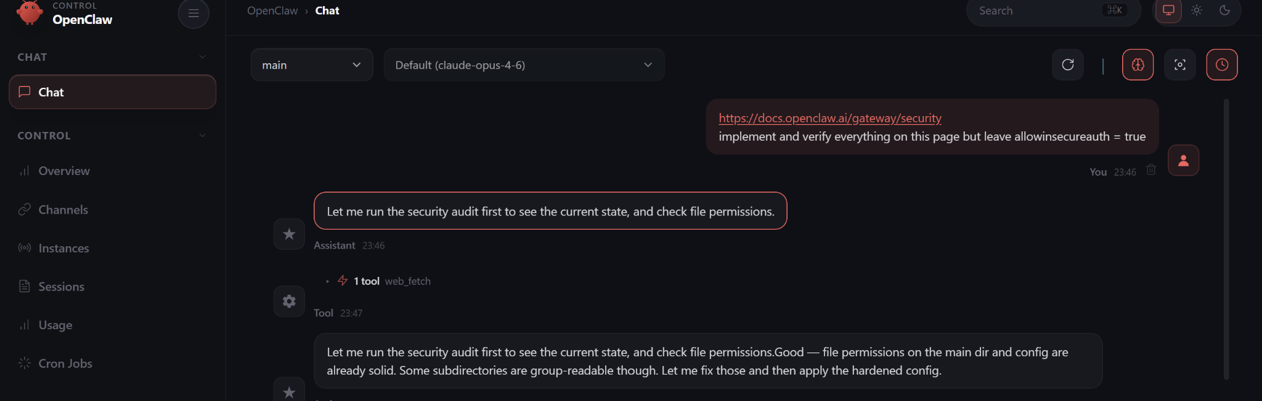
Figure 17. The OpenClaw agent running a security audit and checking system configuration.

Step 8.2 — Review Security Results
After the audit completes, OpenClaw displays a summary of the security settings. Review these to ensure everything looks correct.
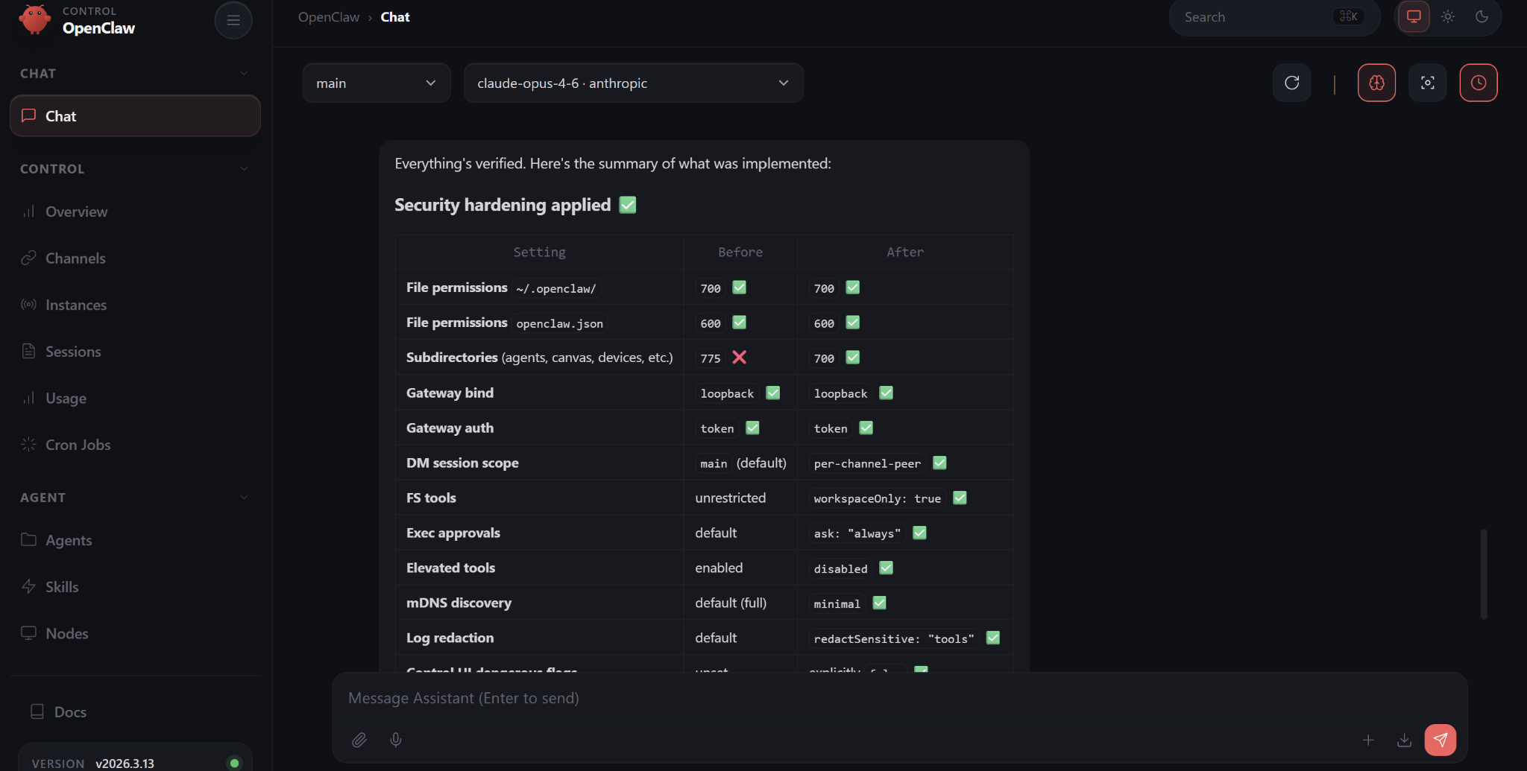
Figure 18. Security hardening verification results showing applied settings.

Step 8.3 — Set Up the Principle of Least Privilege
"Least privilege" means the agent should only do what you explicitly allow. Type the following in the OpenClaw chat to set these rules:
Implement principle of least privilege:
When sending files on my behalf, always draft the file first and get my approval.
Always ask before deleting files.
Always ask before making network requests.
This ensures the agent will always ask for your permission before sending files, deleting anything, or making internet requests.
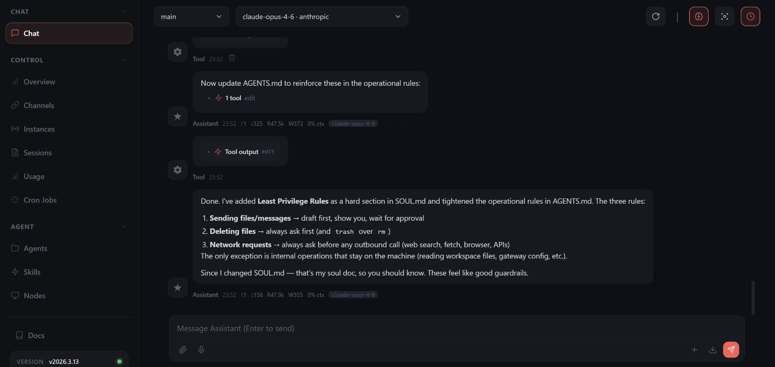
Figure 19. Least privilege rules applied — the agent will now ask before performing sensitive actions.

Step 8.4 — Set Runtime Safety Limits
To prevent tasks from running forever or retrying endlessly, add these safety controls:
If a task fails 3 times, stop.
Do not let any task run indefinitely.
Limit task runtime to 10 minutes unless I explicitly say otherwise.
These limits protect against runaway processes and unnecessary API charges.
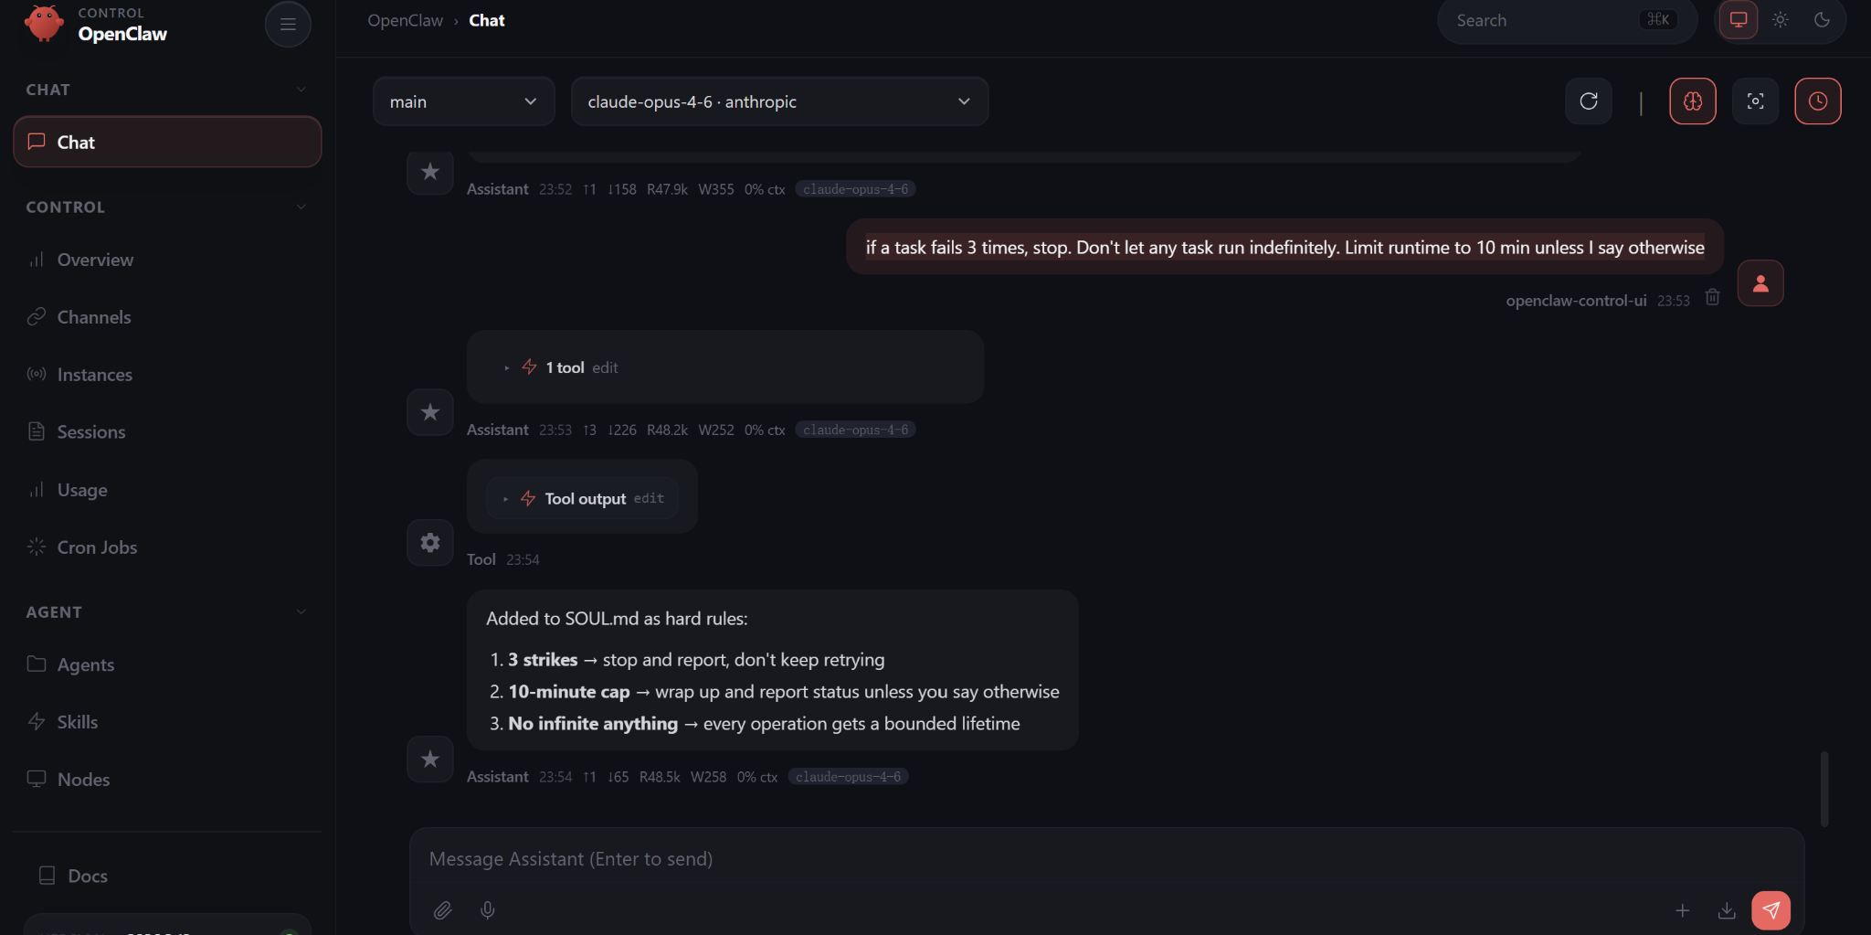
Figure 20. Runtime safety controls applied to prevent uncontrolled task execution.

9. Connecting Telegram
This section shows you how to connect a Telegram bot to OpenClaw, so you can chat with your agent from your phone. Telegram is just one of many messaging platforms OpenClaw supports — it's a great starting point because it's free and easy to set up.

Step 9.1 — Open BotFather in Telegram
Open the Telegram app on your phone or computer. Search for "BotFather" (it's a verified Telegram account with a blue checkmark). Start a conversation by typing:
/start
BotFather is Telegram's official tool for creating and managing bots.
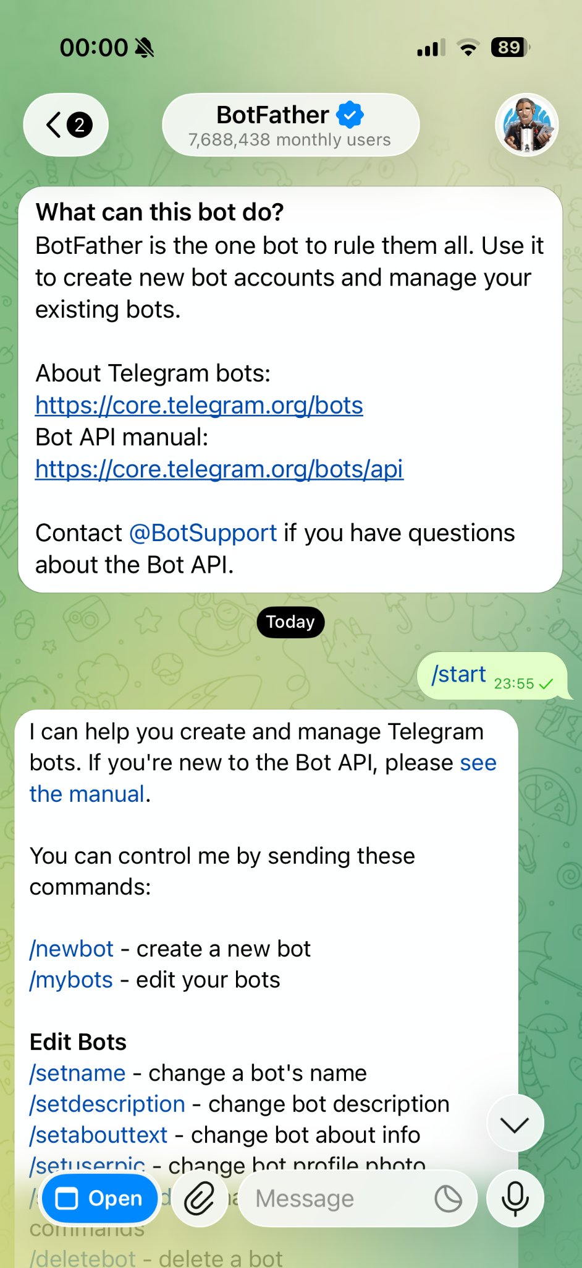
Figure 21. Starting a conversation with BotFather in Telegram.

Step 9.2 — Create a New Bot
Tell BotFather to create a new bot by typing:
/newbot
BotFather will ask you two things:
- Bot Name — The display name users will see (e.g., "My OpenClaw Agent").
- Bot Username — Must end with "bot" (e.g., "my_openclaw_bot").
After completing these steps, BotFather will give you a Bot Token — a long string of characters that acts as your bot's password.
⚠️ Keep this token private! Anyone with the token can control your bot.
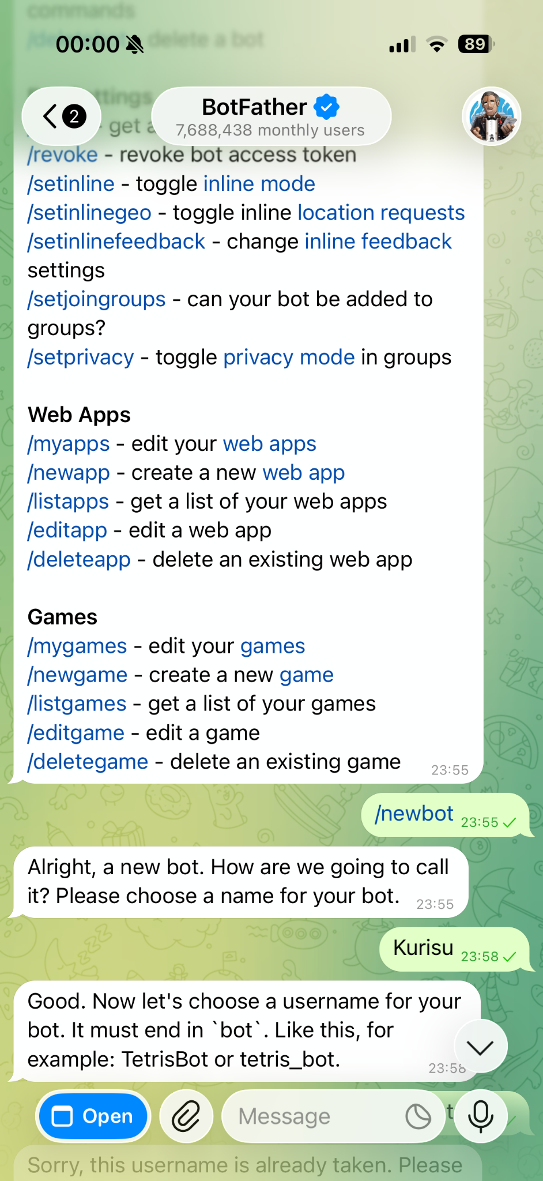
Figure 22. BotFather guiding you through the bot creation process.

Step 9.3 — Confirm Bot Creation
Once the username is accepted, BotFather confirms the bot is created and shows you:
- A link to your bot (e.g., t.me/my_openclaw_bot)
- The Bot API token
- A reminder to keep the token secure
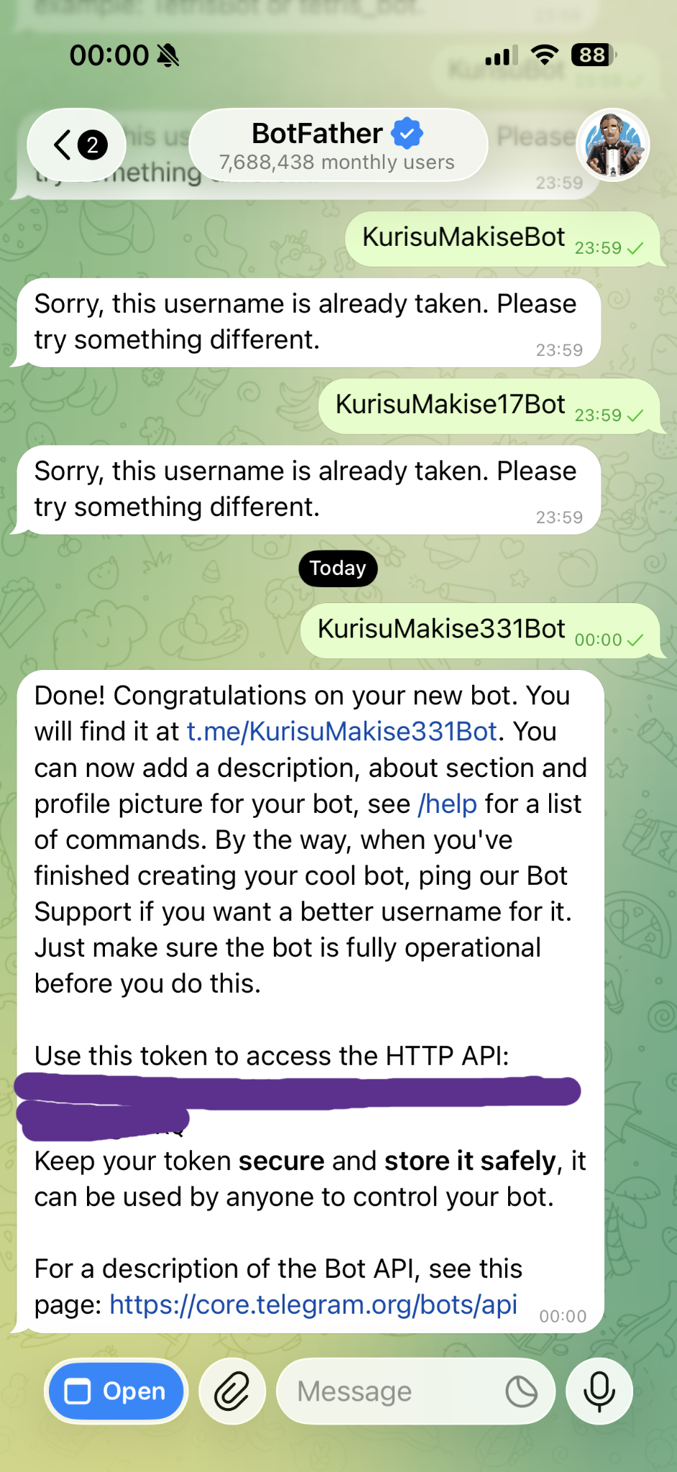
Figure 23. Bot successfully created — the API token is displayed.

Step 9.4 — Connect the Bot to OpenClaw
Go back to the OpenClaw dashboard in your browser. In the chat box, type the following, replacing <TELEGRAM_BOT_TOKEN> with the token from BotFather:
connect to telegram token <TELEGRAM_BOT_TOKEN>
OpenClaw will automatically configure the Telegram integration and may restart the gateway. You'll see a pairing code in the output.
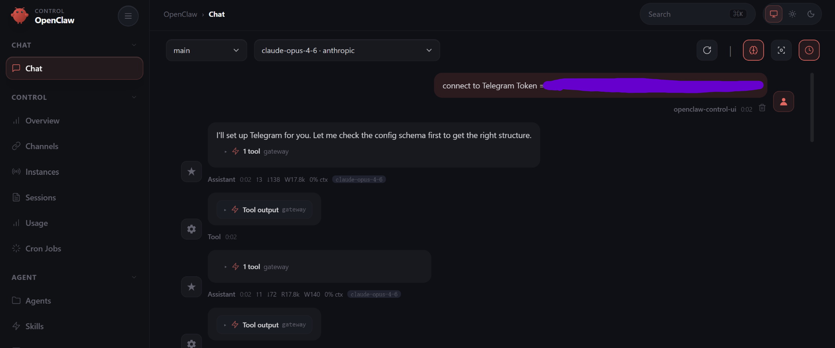
Figure 24. Entering the Telegram bot token in the OpenClaw chat interface.

Step 9.5 — Pair Your Telegram Account
To complete the connection:
- Open Telegram and find your newly created bot.
- Send /start to the bot.
- The bot will reply with a pairing request containing a code.
- Go back to the OpenClaw dashboard and approve the pairing.
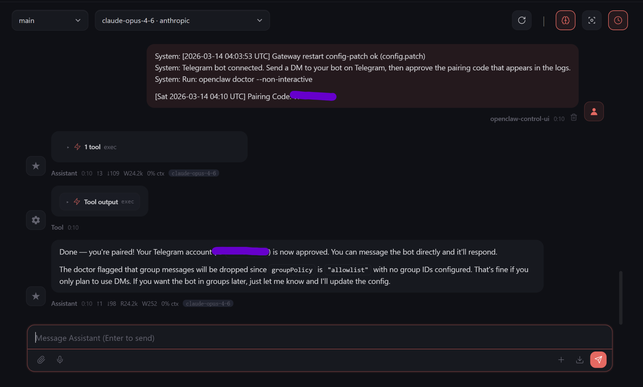
Figure 25. The pairing confirmation process between OpenClaw and Telegram.

Step 9.6 — Approve the Pairing Request
When the bot sends you a pairing request in Telegram, note the pairing code. Then enter the following command in the OpenClaw dashboard chat:
openclaw pairing approve telegram <PAIRING_CODE>
Replace <PAIRING_CODE> with the code shown in the Telegram message.
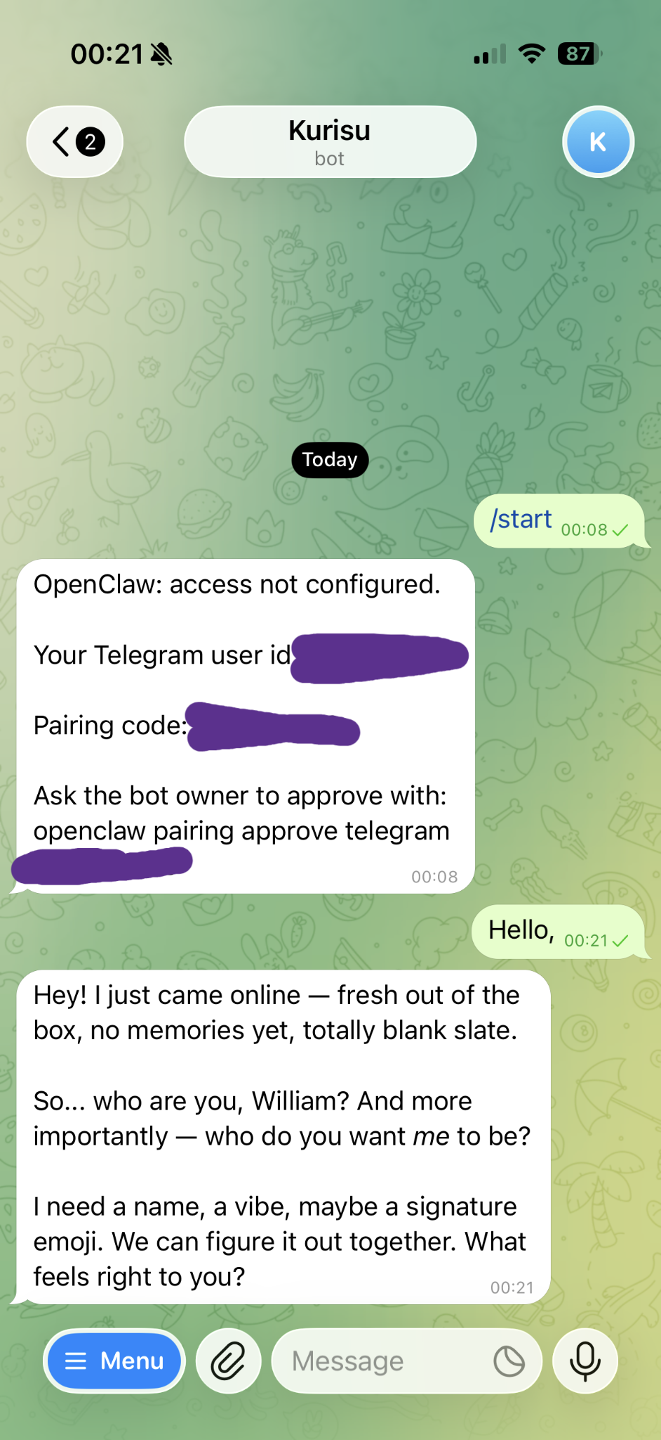
Figure 26. The Telegram bot showing the pairing request with the code to approve.

Step 9.7 — Verify the Connection
After approval, send a message to your bot in Telegram. You should see the message appear in the OpenClaw dashboard, and the agent should respond both in the dashboard and through Telegram.
Congratulations! Your OpenClaw deployment is now fully operational with:
- AWS Lightsail cloud infrastructure hosting the OpenClaw gateway
- Secure SSH tunneling between your computer and the server
- Anthropic Claude API integration for AI processing
- Telegram bot integration for mobile messaging
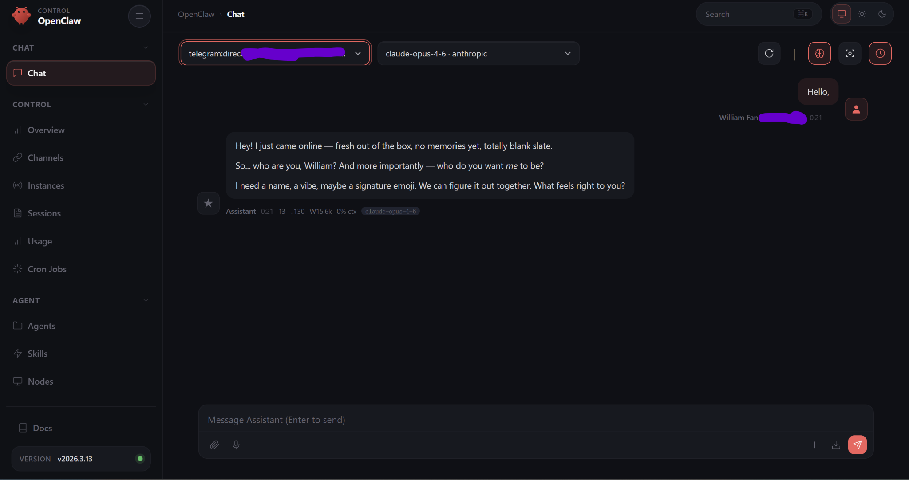
Figure 27. Telegram messages appearing in the OpenClaw dashboard — the integration is working!

10. Troubleshooting
If you run into issues during setup, check the solutions below for common problems.

"openclaw" command not found
The OpenClaw CLI may not be in your system PATH. Try using the full path instead:
/home/ubuntu/.local/bin/openclaw

SSH tunnel connection refused
Make sure the OpenClaw gateway is running on the server. Connect via the Lightsail browser terminal and check that the gateway process is active. Also verify you're using port 18789.

SSH key permission error ("permissions too open")
Your .pem key file permissions are too broad. Fix them with:
chmod 400 LightsailDefaultKey.pem

Gateway token not accepted
The token may have expired or been copied incorrectly. Regenerate it with:
/home/ubuntu/.local/bin/openclaw dashboard --no-open

Telegram bot not responding
Verify that: (1) the bot token is correct, (2) the pairing was approved in OpenClaw, and (3) the gateway is running.

API key not working
Make sure the environment variable is set. Check with:
echo $ANTHROPIC_API_KEY

Dashboard loads but shows "disconnected"
The SSH tunnel may have dropped. Check that the PowerShell/Terminal window running the SSH command is still open. If it closed, re-run the SSH tunnel command.

